University of Wah
Department of Computer Science



Submit to:

Ms. Muniba Khan

Submit by:

Muhammad Talha

Course:

Data Structure and Algorithm_Lab

Reg No:

UW-24-CS-BS-101

Section:

BS-CS-3rd-B

Task # 01
Priority Queue in Ascending Order:
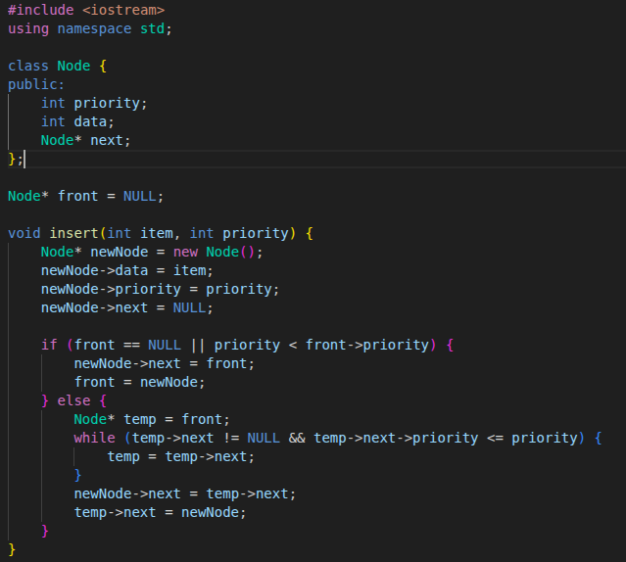
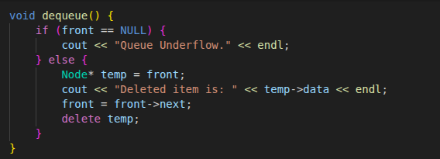

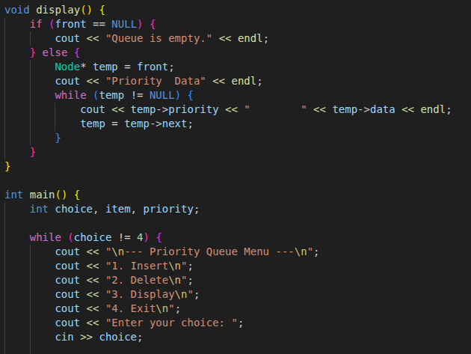
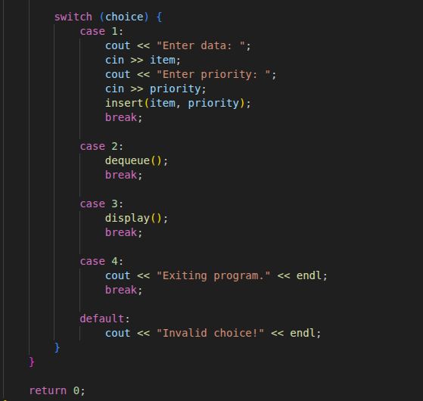

Output
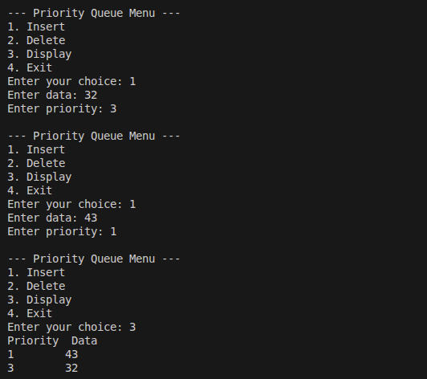

Task # 02
Priority Queue in Decending Order:
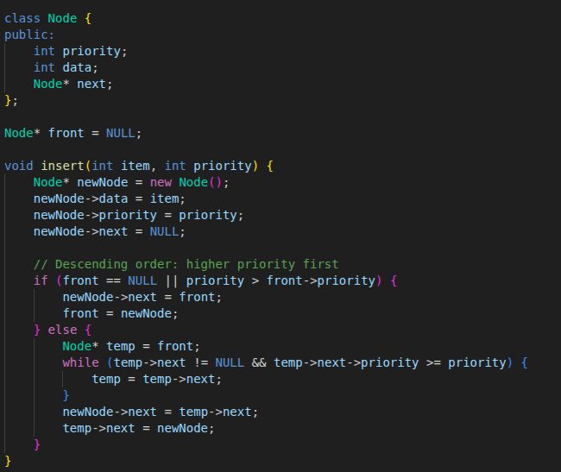
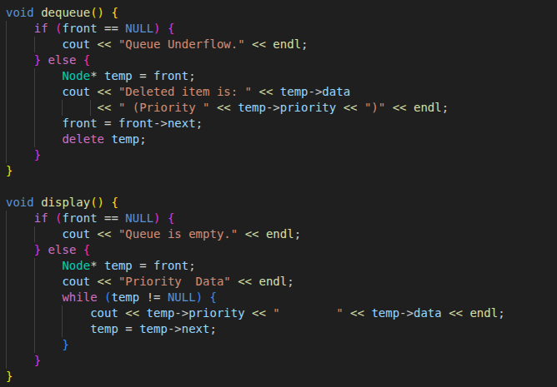
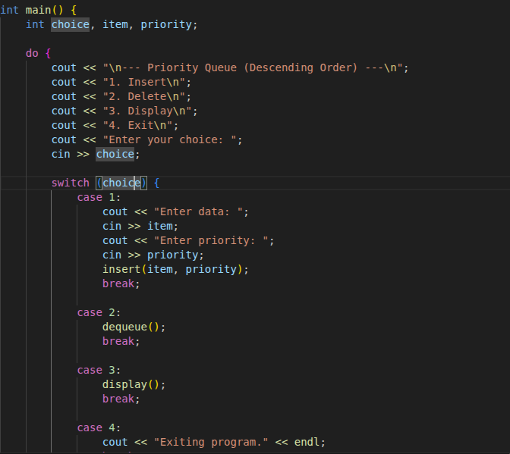

Output

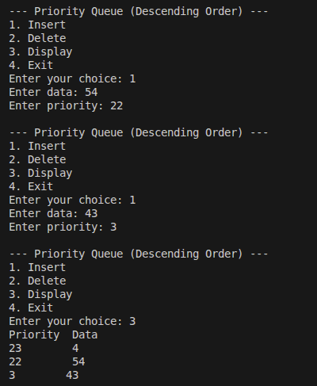

Task # 03

CPU Scheduling
CPU Scheduling is the method used by the operating system to decide which process gets the CPU and for how long.
When many programs want to run, CPU scheduling decides who runs first.

Example:
- CPU cannot run all at once
- OS schedules them one by one

Dijkstra’s Algorithm
Dijkstra’s Algorithm is used to find the shortest path from one node to all other nodes in a graph.
It finds the minimum distance between places.

Example:
- Google Maps finding the shortest route from Home → College
- Network routing (shortest data path)

Event-Driven Simulation
Event-Driven Simulation is a simulation where the system changes only when an event occurs.
Nothing happens until an event triggers a change.

Example:
- Bank simulation:
  - Event 1: Customer arrives
  - Event 2: Teller starts service
  - Event 3: Customer leaves

